*3 INDOOR POSITIONING TECHNIQUES*

”Localization methods are based on the estimation of distance to anchor nodes with known positions and on internode measurements. Node cooperation enhances position estimation and is mostly beneficial when traditional localization techniques fail to produce accurate estimation, as is the case in indoor scenarios.”

*SIGNAL PROPERTIES*

“Signal properties are geometrical parameters consisting of metrics such as angle, distance and signal to measure an object’s position using calculations.”

Angle of Arrival (AOA)

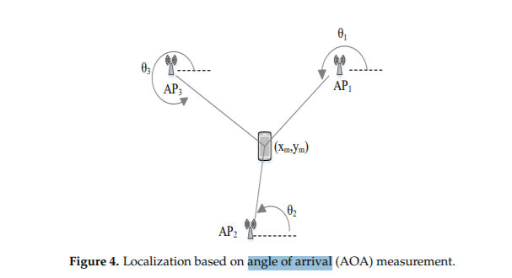

“AOA is the angle and distance calculated relative to two or multiple reference points through the intersection of direction lines between the reference points. The calculation of the angle and distance is used to estimate and determine the position of a transmitter, and the information is used for tracking or for navigation purposes.”

Time of Arrival (TOA)

The TOA is the travel time or time of flight of a radio signal from a transmitter to a receiver. As the signal travels with a known velocity, the distance can be directly calculated from the TOA.

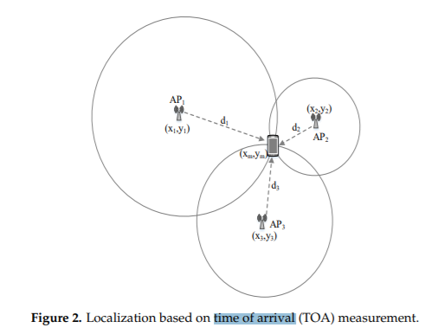

The TOA technique requires precise time synchronization for transmitters and receivers. The estimated distance can be utilized for the trilateration algorithm to estimate user location.

TDOA (Time Difference of Arrival)

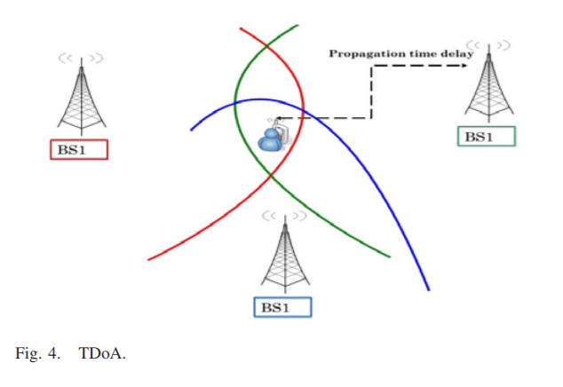

“TDoA examines the time difference at which the signal arrives at many measuring units. The transmitter must lie on a hyperboloid for each TDoA measurement with a constant range difference between the two measuring units. Such measurements are taken between multiple pairs of reference points with known locations. Also, relative time measurements are used at each receiving node in place of absolute time measurements. No synchronized time source is needed by TDoA to perform localization; however, synchronization is only needed at the receivers.”

RSS (Received Signal Strength)

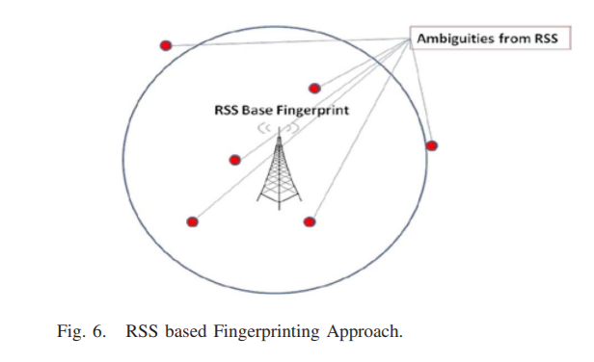

Therefore for each possible location, ambiguity points could exist leading to high estimation errors in standalone positioning scenarios.

F. Common Pitfalls in Stand-Alone Positioning Techniques

Generally, stand-alone positioning techniques suffer from drawbacks affecting the localization accuracy.

3.2 Positioning algorithms

“Positioning algorithms specify how to calculate the position of a target object. In other words, these algorithms translate the recorded signal properties into distances and angles, and then computes the actual position of a target object. For example, when the distance between a target object and the reference points is estimated, the algorithm calculates and determines the position of the object. Both the signal property and the positioning algorithm work together to determine the position of an object. The positioning algorithm processes the signal property and outputs a position.”

“Furthermore, the various positioning algorithms improve the accuracy of a determined position. The accuracy of the information gathered on the position depends on the correctness of the signal property value. In addition, positioning algorithms have unique advantages and disadvantages, hence using more than one type of positioning algorithm at the same time will improve position accuracy and performance. Therefore, several techniques exist for determining position using bearing, range, or proximity information based on signal measurement.”

Triangulation

“In contrast to trilateration, triangulation uses angle measurements in addition to distance measurements to estimate the position of the tag device. Two angles and one length are required for a 2D localization. Particularly, triangulation utilizes the geometric properties of triangles to estimate the tag location.”

Trilateration

“Trilateration is based on measured distances between a tag device and several APs with their known real location coordinates. Given the distance to an AP, it is known that the tag device must be along the circumference of a circle centered at the AP and radius equal to the tag-AP distance. For a 2D localization, at least three noncollinear APs are needed, whereas, for 3D localization, at least four noncoplanar APs are required to perform trilateration operation.”

PROXIMITY?

Scene Analysis / Fingerprinting

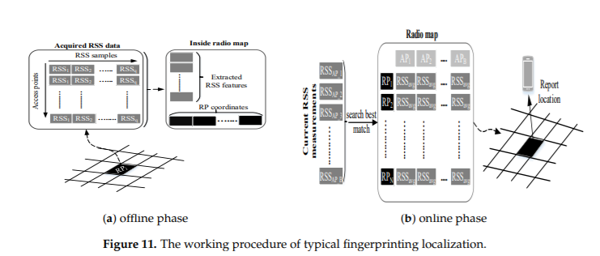

“Fingerprinting is also called scene analysis, where signal strength at reference points (RPs) is measured and stored in the database along with the location of the coordinate of the RPs. For localization, new signal strength is measured and compared with the saved ones to estimate a location.”

“In the offline phase, the area of interest is divided into nonoverlapping hypothetical grids. The typical grid size is 1 m. The data collector goes from one grid to another to collect RSS from hearable APs. In the online phase, the freshly acquired RSS is compared to the stored one to estimate the user’s position.”

“Fingerprinting is the most widely used indoor localization method due to its good localization accuracy and nonrequirement of LOS measurements of APs. The technologies like Wi-Fi, BLE, and geomagnetic field can be used to realize the fingerprinting localization. Although fingerprinting localization has good localization accuracy, it comes with a time-consuming and labor-intensive offline phase.”

Indoor Positioning Technologies

“In this section, several existing technologies which have been used to provide indoor localization services will be presented and discussed.”

“While there is a number of localization systems based on camera/vision technologies, such systems are beyond the scope of this survey and will not be discussed here.”

“Given that positioning and navigation development employ variety of algorithms and techniques, navigation technologies vary in their application. While many technologies have evolved for positioning and navigation, the prevalent ones for indoor environments are the focus of this section”

“Without the current location, planning or rerouting a path to the destination is difficult with any device; thus, navigation becomes cumbersome. Additionally, when a pedestrian does not know where he/she is while trying to locate a destination without a device, it is difficult to know the exact route to take towards the destination. The individual is considered lost. For this not to happen, certain technologies and techniques help in determining an individual’s current location. For example, celestial bodies, natural landmarks, points-of-interest or known buildings, radio signals and satellite signals aid position determination.”

Ultrasound

“Just like the IR positioning system, the Ultrasound positioning system has high accuracy at room level. Some Ultrasound positioning systems use either narrowband or broadband signals that have shown high-accuracy level during implementation. Ultrasound positioning systems involve the use of ultrasonic tags or nodes on users and objects. These tags or nodes serve as receivers or transmitters; when one is stationary or fixed, the other will be in motion.”

*Challenges and drawbacks of Ultrasound*

“In general, and based on the afore-discussed, the ultrasound signal’s characteristics, such as slow propagation signal speed when compared with speed of light, negligible penetration in walls and lowcost of transducers, make it interesting for studies in indoor positioning systems. The advantages of the ultrasound positioning system when compared with other positioning systems include improved accuracy and performance, low-cost and scalability.”

“On the other hand, implementing on a large scale will degrade the advantages in this system. Ultrasonic positioning systems are expensive to deploy and maintain on a large scale. They are usually inexpensive at room level.”

“In addition, ultrasound systems suffer from multipath effects such as noise, reflection and interference. Hence, system accuracy and performance is degraded.”

Bluetooth

“Bluetooth (or IEEE 802.15.1) consists of the physical and MAC layers specifications for connecting different fixed or moving wireless devices within a certain personal space. The latest version of Bluetooth, i.e., Bluetooth Low Energy (BLE), also known as Bluetooth Smart, can provide an improved data rate of 24Mbps and coverage range of 70-100 meters with higher energy efficiency, as compared to older versions . While BLE can be used with different localization techniques such as RSSI, AoA, and ToF, most of the existing BLE based localization solutions rely on RSS based inputs as RSS based sytems are less complex. The reliance on RSS based inputs limits its localiztion accuracy.”

Challenges and drawbacks of Bluetooth based positioning

In summary, even though ble is innovating, ble-based positioning systems possesses unique problems. Both the range (coverage) and signal for radio waves are limited. They are also prone to disturbance, as certain electronics, storms and even organic matters can disturb or distort radio signals. As an RF signal travels through the air and other mediums in an indoor environment, it exhibits certain behaviours or propagation effects such as absorption, reflection, scattering, refraction, interference, multipath and attenuation. These behaviours are signal impediments that affect a signal’s transmission between two locations thereby causing significant loss and degradation of the received signal. Their effects could sometimes be unhelpful and have a negative effect on performance and accuracy.

Ultra-wideband (UWB)

“UWB uses very low energy for short-range and high-bandwidth communications over a large portion of the radio spectrum. In general, an emitted radio wave is considered UWB if its bandwidth exceeds 500 MHz or 20% of the carrier frequency. The properties of UWB, such as very less power consumption, effective penetration through dense materials, and less sensitive to the multipath effect owing to a very short duration of UWB pulses make the UWB suitable for IPS development.”

*Challenges in UWB-Based Localization System*

The performance of positioning systems based on UWB technology may face many challenges induced by aspects such as extremely cluttered operational environments causing multipath, NLOS and shadowing artifacts

Another big challenge of UWB based localization resides in implementing wideband radio devices for a UWB signal with absolute bandwidth larger than 500 MHz. Here, some efforts have been done in the research community to develop such platforms reaching 10 to 15 cm in positioning accuracy.

In UWB-based positioning system, interference with the ultra-wide spectrum may occur because of the misconfiguration. Interference may occur also due to the spread of the UWB signal over the bandwidths containing the frequency of the existing narrowband system.

Another challenge resides in the need of, at least three receivers with unblocked direct path to the transmitter for normal ToA positioning algorithm. UWB-based positioning system requires also signal acquisition, tracking, and synchronization to be performed with very high precision in time relative to pulse rate. Currently, researchers are working on such problems.

Wi-Fi

“The IEEE 802.11 standard, commonly known as WiFi, operates in the Industrial, Scientific, and Medical (ISM) band and is primarily used to provide networking capabilities and connection to the Internet to different devices in private, public and commercial environments. Initially, WiFi had a reception range of about 100 meters which has now increased to about 1 kilometre (km), in IEEE 802.11ah (primarily optimized for IoT services”

Since existing WiFi access points can be also used as reference points for signal collection, basic localization systems (that can achieve reasonable localization accuracy) can be built without the need for additional infrastructure. However, existing WiFi networks are normally deployed for communication (i.e., to maximize data throughput and network coverage) rather than localization purposes and therefore novel and efficient algorithms are required to improve their localization accuracy.

*Challenges in WLAN-Based Localization System*

WLAN-based localization system is time consuming for site surveying and is labor intensive. Another challenge is the fact that the multipath of such systems is influenced by the existence of physical objects. Also, WLAN-based localization system may interfere with other applications in the 2.4 GHz ISM. Moreover, the variation of signal strength with respect to time is considered a weakness of such system causing deterioration in the localization accuracy. The variation of signal strength caused by the movement of people, doors, and furniture in offices requires updating simultaneously the signal strength map. Hence, this is considered as a main drawback of WLAN fingerprinting systems.

Dead Reckoning

“PDR is Dead Reckoning (DR) for pedestrians. DR is the process of estimating one’s current position by using a previously known position and the time it was obtained, and predicting a future position based on known direction and speed over a period. DR works even when radio navigation like the GPS fails and bad weather renders visual techniques impossible. It can give accurate information on position, but is subject to cumulative errors over a long period.”

*The Performance Metrics*

Several research works have contributed to the development of indoor positioning and navigation by tackling issues, challenges and limitations in these solutions. However, there are still issues which need to be addressed. These issues are with respect to accuracy, complexity, privacy and usability among others are outlined in this section

Accuracy

“One of the most important feature of the localization system is the accuracy with which the user/device position is obtained. As mentioned earlier, indoor environments due to presence of obstacles and multipath effects provide a challenging space for the localization systems to operate in. Therefore, it is important for the system to limit the impact of multipath effects and other environment noises to obtain highly accurate systems. This might require extensive signal processing and noise elimination that is a highly challenging task. The localization system should be able to locate the user or object of interest ideally within 10 cm (known as microlocation) accuracy.”

Cost

“The cost of localization system should not be high. The ideal system should not incur any additional infrastructure cost as well as do not require any high end user device or system that is not widely used. The use of proprietary RNs/hardware can improve the localization accuracy, however it will certainly result in extra cost. While larger companies might be able to afford them, smaller businesses are constrained mostly in terms of such costs. Therefore, we believe that the localization system can easily penetrate the consumer market and be widely adopted by keeping the cost low”

Energy Efficiency

“Energy efficiency is of primary importance from localization perspective. The goal of localization is to improve the services provided to the users. Any such system that consumes a lot of energy and drains the user device battery might not be widely used. This is because localization is an additional service on top of what the user device is primarily intended for i.e. communication. Therefore, the energy consumption of the localization system should be minimized. This can be achieved by using technology such as BLE that has lower energy consumption or offloading the computational aspect of the localization algorithm to a server or any entity which has access to uninterrupted power supply and has high processing power. The fundamental trade off is between the energy consumption and the latency of the localization system.”

Scalability

“A scalable positioning system means that it functions properly when its scope gets larger. Usually, the performance of localization reduces with the increase in the distance between the transmitter and receiver. Further, a positioning system may require scaling on 2 axes, density and geography. Geographic scaling represents the coverage of an area or volume, whereas density scaling represents the number of units positioned per unit geographic space or area per time period. Wireless signal channels may turn out to be congested as more area is covered or the units in such area are crowded; hence, further computation or communication infrastructure may be required to do localization. In addition, the dimension of a system is another metric for scalability. A positioning system may locate objects in 2-D space, 3-D space or in both.”

*Applications*

In this section, we detail the main applications of localization in indoor environments. Indoor positioning and navigation for mobile devices is a market with expected size of 4 billion $ in 2018. A reliable, user-friendly, and accurate solution for indoor positioning and navigation might open the doors to the definition of new applications and the creation of new business opportunities in countless scenarios, and is indeed considered as a cornerstone in the realization of the Internet of Things vision. It is worth mentioning that some of these applications could be also applied in outdoor scenarios.

E. Asset Management and tracking detection of the location of products in the warehouse;

Asset management can fundamentally benefit from tracking as it would allow different businesses to track the location of their assets. It will also allow for better inventory management and optimized operation management. While asset management and tracking has been extensively discussed in literature [134]–[141], we believe that the advent of IoT along with accurate indoor localization system will revolutionize asset management and tracking. Use of novel energy efficient techniques and algorithms will eliminate the need for expensive proprietary hardware that is currently used in the industry and different firms.

B. Health Services monitoring patients, staff, and equipment in the hospitals to improve navigation;

Health sector can greatly benefit from indoor localization as it can help save valuable lives. It can help both the hospital staff, the patients as well as the visitors If a patient needs medical assistance, the current protocol requires broadcasting the message or paging a specific doctor or staff member who may not be in vicinity of the patient. The delay in the arrival of the staff might even cause the death of the patient. Similarly, broadcasting the message will cause other staff members to receive irrelevant messages. A location based solution would allow to track the position of the staff members. In case of emergency, the localization system would find the staff member who is in close vicinity and has the necessary qualification to handle the emergency situation. This will avoid the aforementioned delay as well as not spam the other staff members. Indoor localization can also allow the doctors to track various patients and track their mobility to ensure patient safety. Visitors who intend to visit patients can find their destination using a localization system without any hassle.

A. Contextual Aware Location based Marketing help customers locate stores or products in a shopping mall;

“Similarly, other environments such as libraries and airports can also greatly benefit from location based services. In libraries, the visitors can find a specific book and the location of the book using localization. Similarly, the library can also provide the student with relevant information based on the location. In airports, localization can allow the customers to find their respective boarding gates or terminals without any hassle and wastage of time. Major airports such as John F. Kennedy (JFK) in New York, Heathrow London, Miami International and many more have started using iBeacons to provide proximity based services to the travellers and improve overall customer experience [133]. In fact, Japan airlines uses MBL to obtain the location of its staff and accordingly assign tasks [133] in Tokyo Haneda Airport.”

C. Location-Based Services detecting the location to find the place where the car was parked in a parking lot.

!Location-based Services (LBS) are defined generally as service that outspreads GIS capabilities or spatial information to end users through wireless networks and/or the Internet. Yet, LBS applications can offer the context and the connectivity needed to dynamically associate the position of a user to context-sensitive info about current environments; whereas conventional GIS applications are concentrated on geographical information for land planning and management. Hence, high level of personalization is achieved with LBS applications that simplify a capability of making each user the center of his universe. LBS send data dependent on context and accessed by a mobile device by knowing the geographical location. LBS service is required for indoor and outdoor environments. For instance, indoor LBS include applications to obtain safety information or up-to-date data on cinemas, events or concerts in the vicinity. Further applications of this type include a navigation application used to direct a user to the target store in a public building. Moreover, LBS are used for advertisements, billing, and for personal navigation to guide guests of tradeshows to the targeted exposition booth. Also, LBS applications can be used at bus or train stations to navigate to the bus stop. Likewise, LBS are used for notification based on proximity, automated logon/logoff tasks in institutions and the profile matching.”